America or the United States
Read the text. Translate the words you don’t know (dictionary!) Write them into your Words and Phrases.
What two countries are larger than the US? Discuss with a partner.
The continent of America is made up of two vast land masses: North America and South America. They are connected to each other by the Central American isthmus (a thin strip of land).
North America consists of three main countries: Canada, the United States and Mexico. The United States is the third-largest country in the world. It is so big that when it’s 12 o’clock in New York, It’s only 9 o’clock in San Francisco and 7 o’clock in Hawaii and Alaska! Because the United States is so big it has a huge variety of natural landscapes and climates.
Who really discovered America?
An Italian explorer, Christopher Columbus, is generally given the credit for discovering America. But when Columbus landed in the Bahamas in 1492, the people greeting him on the beach had arrived there some 20.000 years before. They had crossed a land bridge that connected the most northern point of America to Asia.
Columbus can’t even claim to be the first European to set foot in the “New World”. The Native Americans told him the legend of a “fair-skinned, blue-eyed god” who would one day return from across the sea.
Who was this “fair-skinned god”? What do you think?
- In 500 AD an Irish monk, Saint Brendan, left Ireland on a seven-year sea journey, in search of the Garden of Eden. He reached America.
- A Welsh prince, Prince Madoc, left Wales in 1176 to escape fighting. When he returned home, he was speaking of a “warm and golden land, far across the sea”.
- A Viking, Leif Erikson, travelled to North America in 1001 AD. Erikson grew up in Iceland. His family had to move to Greenland. When Leif grew up he discovered Newfoundland in Canada.
Listen to the podcast (CD) and write the states under the photographs. Which one would you most like to visit? Why?
Describe 2 states (into your Exercise book)!
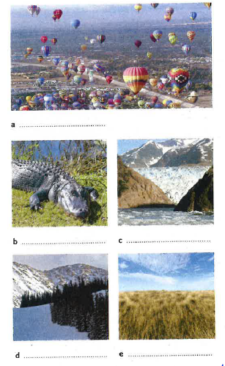
The United States – Declaration of Independence
Columbus was the first in a long line of people to come to America in hope of a new and better life. Spanish, French and British settlers set up colonies (which are now known as states) and claimed the territory for themselves. Most of the British colonies were on the east coast. The settlers were still under British rule and had to pay taxes to Britain.
Thirteen colonies joined forces and declared war against the British in 1775, and in 1776 Thomas Jefferson wrote the American Declaration of Independence. The colonies won the War of Independence in 1783 and together they formed the United States of America, with George Washington as the first President. Representatives from 12 of the 13 states of the United States wrote the American Constitution. Shortly after that, other states joined the Union. Nowadays there are 50 states in the United States.
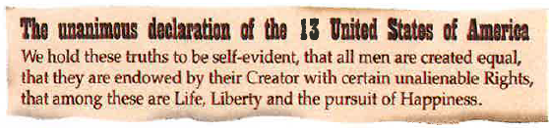
Answer the following questions:
Why did the European settlers come to America?
………………………………………………………………………………………………………………
How are the colonies called nowadays?
………………………………………………………………………………………………………………
Where were most of the British colonies located?
………………………………………………………………………………………………………………
Were the colonies able to govern themselves (what did they have to do)?
………………………………………………………………………………………………………………
Who declared war against the British in 1775?
………………………………………………………………………………………………………………
Who wrote the American Declaration of Independence, and when?
………………………………………………………………………………………………………………
Who won the War of Independence?
………………………………………………………………………………………………………………
Who was the first President of the United States?
………………………………………………………………………………………………………………
Who wrote the American Constitution?
………………………………………………………………………………………………………………
How many states are in the US nowadays?
………………………………………………………………………………………………………………
Listen and fill in the captions on the flag below.
