Native Americans – Questions
- How many Native Americans lived in North America, when the white man first came to the continent?
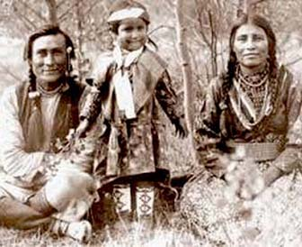
- Did the white settlers live in peace with the Native Americans?
- Did the Native Americans get help after the Indian wars?
- Describe (Beschreibe) the reservations for the Native Americans!
- A lot of Native Americans died. Why?
- How many Native Americans are there in the US today?
- What is a big problem for them today?

Native Americans – Questions
- How many Native Americans lived in North America, when the white man first came to the continent?
- Did the white settlers live in peace with the Native Americans?
- Did the Native Americans get help after the Indian wars?
- Describe (Beschreibe) the reservations for the Native Americans!
- A lot of Native Americans died. Why?
- How many Native Americans are there in the US today?
- What is a big problem for them today?

