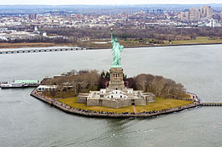
The Statue of Liberty in New York!
Read the text again and answer the following questions into your Exercise book!
1. Where is the Statue of Liberty located?
2. What did most of the immigrants see when they came to New York?
3. Who gave the Statue of Liberty to America and why?
4. Who designed the Statue of Liberty?
5. How did the Statue of Liberty come to New York?
6. Why isn’t it possible to walk up the staircase inside the Statue of Liberty?
7. Why is the Statue of Liberty one of the most popular sights in New York?

The Statue of Liberty in New York!
Read the text again and answer the following questions into your Exercise book!
1. Where is the Statue of Liberty located?
2. What did most of the immigrants see when they came to New York?
3. Who gave the Statue of Liberty to America and why?
4. Who designed the Statue of Liberty?
5. How did the Statue of Liberty come to New York?
6. Why isn’t it possible to walk up the staircase inside the Statue of Liberty?
7. Why is the Statue of Liberty one of the most popular sights in New York?

